**AS 3959 cases**

Comparison of radiative heat flux of AS 3959 method and simulaton.

The radiative heat flux was calculated according to the given method in AS 3959 standard.

During the calculation procedure following parameters were assumed.

* Ambient temperature ($T_{a}$) =308 K (35 0C)
* Relative humidity (RH) = 25%
* Flame emissivity ($ε$) = 0.95
* Flame temperature ($T_{f}$) =1090 K

Basic equations:

1. The radiant heat flux (kW/m2)
2. Flame emissive power

$$E=σεT_{f}^{4}$$

We consider only the flat land (vegetation and site at the same tevel). So $θ=0$ in the caclculation and flame center is over the ground level.

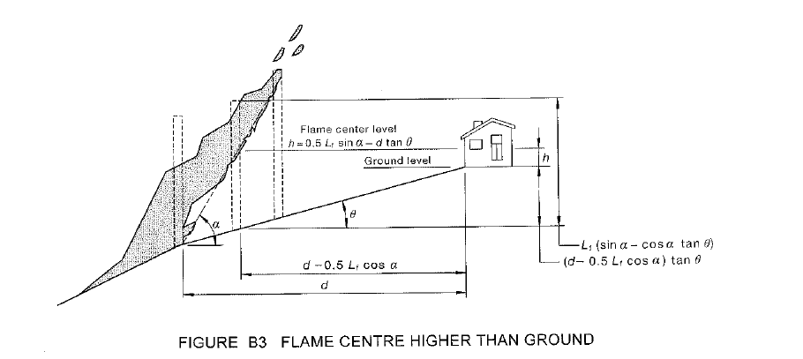

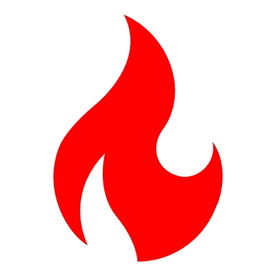

Finding flame angle using the algorithm given in AS 3959 standard (Figure B4, page 10 in 2018 version)

|  |
| --- |
|  |

Alogithm written in python (flameAngle.py)

Correlations

$$∅=f\left(X_{1},X_{2},Y_{1},Y_{2}\right)$$

$$X_{1},X_{2}=f(L_{f},α, θ, h, d)$$

$$Y_{1},Y_{2}=f(W_{f},L_{f},α, d)$$

Therefore $$∅=f\left(L_{f},α, θ, h, d,W_{f}\right)$$

There are different view factors ($∅$) for different distances (d) from vegetation to site. Flame angle was calculated for the $∅_{max}$ of each FDI case

|  |  |
| --- | --- |
| Case | Flame angle ($α$) |
| FDI 50 | 34.2340 |
| FDI 80 | 35.6900 |
| FDI 100 | 36.9660 |

Comparison of simulation and calculated radiative heat flux

|  |
| --- |
|  |

Firebrands flux and Radiative flux

|  |
| --- |
| Firebrands flux and Radiative heat flux vs BAL |
| Firebrand flux vs Radiative heat flux in different BAL |